CaptionAI: AI-Powered Social Media Caption Generator

Project Description:

Automating standard laptop procurement streamlines the Request Fulfillment process in ServiceNow. Utilizing ServiceNow Flow Designer and Service Catalog, this system enables employees to request pre-approved laptop configurations with automated approvals, dynamic asset allocation, supplier REST API integrations via IntegrationHub, and real-time status tracking.

The solution eliminates manual email handoffs, reduces hardware provisioning cycle time from days to hours, and maintains complete auditability across Request (REQ), Requested Item (RITM), and Service Catalog Task (SCTASK) records.

Scenarios

Scenario 1: Standard Employee Laptop Request
An employee requests a standard business laptop through the Service Portal. Because the item cost is under the pre-approved budget threshold, Flow Designer bypasses manual manager approvals, checks local stock in ServiceNow Asset Management (alm_hardware), creates a provisioning task for Desktop Support, and updates the user with tracking details within seconds.

Scenario 2: High-Performance Developer Laptop Request
A developer selects a high-spec workstation requiring additional expenditure. Flow Designer dynamically identifies the requester's direct manager and IT Finance approver. It holds execution until digital approvals are logged in the system, then automatically generates a Purchase Order (PO) payload sent directly to vendor APIs (e.g., Dell, Lenovo, or HP) via IntegrationHub.

Scenario 3: Onboarding Batch Hardware Procurement
An HR Manager submits a batch request for multiple incoming employees. Flow Designer processes the request, spawns individual RITM records for each employee to maintain granular asset tracking, triggers parallel fulfillment tasks for staging and imaging, and initiates automated shipping label generation.

Technical Architecture:
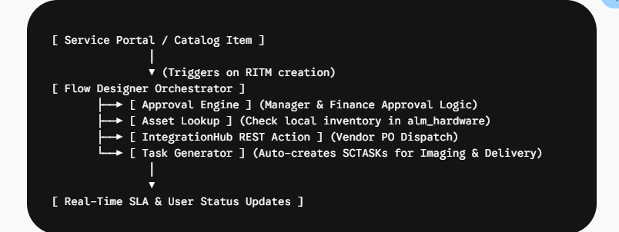
• Presentation Layer (Service Portal): Configured with dynamic Catalog Items, variable sets, dynamic pricing calculators, and User Criteria entitlement rules.
• Process Engine (Flow Designer): Serves as the core workflow orchestrator. It evaluates business rules, handles conditional branching, controls approval matrices via sys_approval, and manages task lifecycle states.
• Integration & Asset Layer (IntegrationHub & ITAM): Connects to external distributor systems via REST spokes for inventory checks and automated purchasing while updating the internal hardware asset database in real time.

(Note: If you are using database in your project definitely you need to add ER Diagram along with description)

Pre-requisites:

ServiceNow Administration & Development: Core knowledge of Catalog Items, Variable Sets, and sys_user dynamic queries.
Flow Designer & IntegrationHub: Hands-on experience with Flow logic, Subflows, Flow Variables, and REST Spokes.
Scripting (JavaScript / GlideAPI): Basic proficiency in GlideRecord and script transforms for complex data parsing.
IT Asset Management (ITAM) & ITSM: Understanding of Request Fulfillment lifecycle (REQ $→$ RITM $→$ SCTASK) and asset state transitions.
REST API Integration: Familiarity with JSON payload structures, OAuth 2.0 / API key authentication, and endpoint testing.

Project Workflow:

1. Request Stage (REQ & RITM)
- Trigger: Employee submits a hardware request via the Service Portal.
- Record Generation: ServiceNow generates a parent Request (REQ) number and a child Requested Item (RITM) record containing all variable details (e.g., Requester Name, Delivery Location, Laptop Specifications).
2. Process & Approval Stage (Flow Designer)
- Trigger Event: The Flow listens for new sc_req_item entries matching the Standard Laptop Catalog Item.
- Evaluation:
  - Auto-Approval: Standard configurations trigger immediate execution without manual intervention.
  - Dynamic Approval: Custom or high-spec items route an approval notification to the requester's direct manager (sys_user.manager) or IT Finance team.
3. Sourcing & Task Assignment Stage (sc_task)
- Inventory Query: Flow Designer queries the Hardware Asset table (alm_hardware) for in-stock models.
- Task Routing: Upon approval, the Flow automatically creates a Catalog Task (sc_task):
  - Short Description: Updated dynamically with user context (e.g., Provision and Image Standard Laptop for [User]).
  - Assignment Group: Automatically assigned to the Hardware support group.
4. Fulfillment & Asset Lifecycle Stage
- Provisioning: Hardware team receives the task, images the laptop, updates asset tags, and issues the device.
- Cascade State Update: Closing the sc_task triggers the Flow to update the RITM to Closed Complete, updating the parent REQ state and notifying the requester.

Activity 1: Create Flow for Approved Laptop Request Task Creation
Objective
Create a workflow using ServiceNow Flow Designer that triggers when a Laptop Catalog Item is requested. After manager approval is secured, the flow generates a Catalog Task (sc_task) assigned to the Hardware group with a specific updated short description.
Step-by-Step Implementation Guide
Step 1: Create and Trigger the Flow
- Navigate to All > Flow Designer in your ServiceNow instance.
- Click New > Flow.
- Set the Flow properties:
  - Flow Name: Automate Laptop Request - Hardware Task Creation
  - Description: Creates a hardware catalog task upon service request approval.
  - Run As: System User (or User who initiates session).
- Click Submit.
- Under Trigger, click Add a trigger:
  - Trigger: Created
  - Table: Requested Item [sc_req_item]
  - Conditions: Item IS [Your Laptop Catalog Item Name] (e.g., Standard Business Laptop)
  - Click Done.

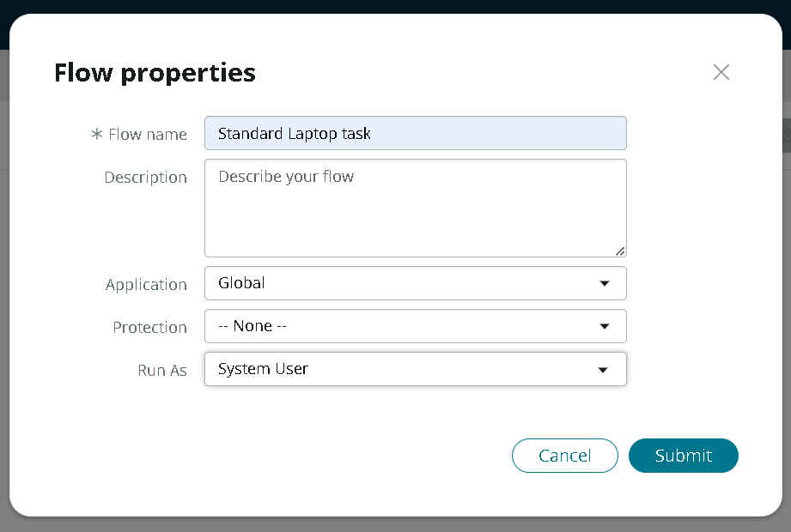
Step 2: Add Approval Logic
- Under Actions, click Add an Action, Flow Logic, or Subflow.
- Select Action > ServiceNow Core > Ask For Approval.
- Configure the Action:
  - Record: Drag and drop the Requested Item Record from the Data Panel on the right.
  - Approval Field: Approval
  - Rules: Choose Approve when $→$ Anyone approves.
  - Approver(s): Select Manager via Data Pill Picker (Trigger - Record > Requested Item > Requested For > Manager) or select a specific IT Approver group/user.
- Click Done.
Step 3: Add Conditional Logic for Approval
- Click Add Flow Logic > If.
- Label: If Approved.
- Condition: Drag Ask for Approval > Approval State IS Approved.
- Click Done.
Step 4: Update Requested Item State (Optional Best Practice)
- Inside the If Approved branch, click Add an Action.
- Select Action > ServiceNow Core > Update Record.
- Configure:
  - Record: Trigger - Record > Requested Item Record
  - Fields:
    - State $→$ Work in Progress
    - Stage $→$ Fulfillment
Step 5: Create Catalog Task (sc_task)
- Inside the If Approved branch, click Add an Action.
- Select Action > ServiceNow Core > Create Catalog Task.
- Configure the Task details:
  - Requested Item: Drag and drop Trigger - Record > Requested Item Record.
  - Short Description: Enter your updated descriptive text:
Provision and Image Standard Laptop for + Drag Trigger - Record > Requested Item > Requested For > Name
  - Fields / Task Specifications:
    - Assignment Group: Search and select Hardware.
    - Priority: 3 - Moderate (or map from RITM priority).
    - State: Open or Pending.
- Click Done.
Step 6: Handle Rejection (Else Branch)
- Below the If Approved block, click Add Flow Logic > Else.
- Click Add an Action > ServiceNow Core > Update Record.
- Configure:
  - Record: Trigger - Record > Requested Item Record
  - Fields:
    - Approval $→$ Rejected
    - State $→$ Closed Cancelled
    - Stage $→$ Request Cancelled

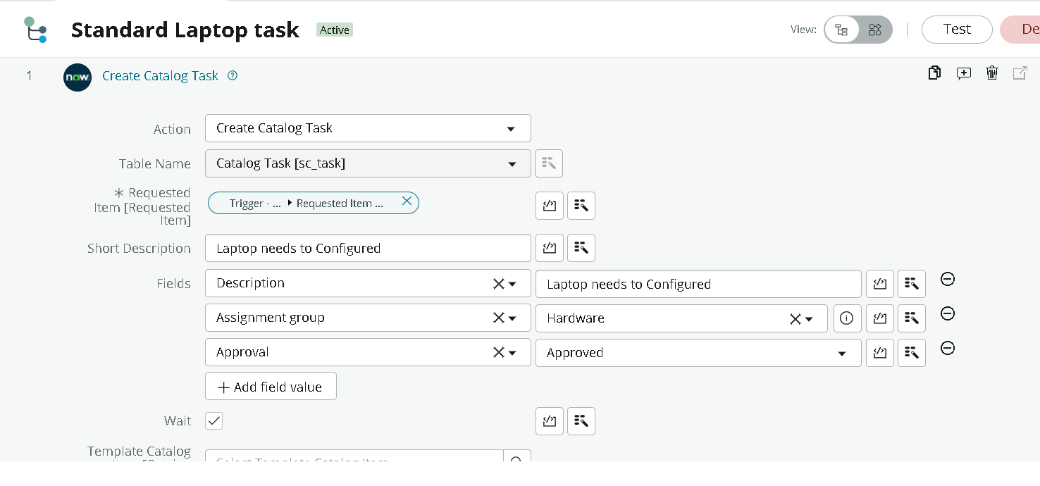
Step 7: Test and Publish
- Click Save in the top right corner.
- Click Test to run the flow against an existing test RITM record.
- Review the execution details in the Execution Details / Flow Log window to verify:
  - Approval step triggers accurately.
  - sc_task is created with the updated Short Description.
  - Task Assignment Group is correctly set to Hardware.
- Click Publish to make the flow active.

Activity 2: Associate Flow with Standard Laptop Service Catalog Item
Objective
Link the Flow created in Activity 1 (Automate Laptop Request - Hardware Task Creation) directly to the Standard Laptop Catalog Item so ServiceNow knows to execute this specific process whenever a user submits that request.
Step-by-Step Implementation Guide
Step 1: Open the Catalog Item Configuration
- In the ServiceNow main navigation bar, go to All > Service Catalog > Catalog Definitions > Maintain Items.
- Search for your Catalog Item in the list (e.g., Standard Laptop or Standard Business Laptop).
- Click on the item name to open its Catalog Item record.
Step 2: Configure Process Engine Settings
- Scroll down to the Process Engine tab on the Catalog Item form.
- Ensure the Workflow and Execution Plan fields are cleared/blank (ServiceNow prioritizes legacy Workflows over Flows if both are populated).
- Locate the Flow field.
- Click the magnifying glass / search icon in the Flow field, search for Automate Laptop Request - Hardware Task Creation, and select it.

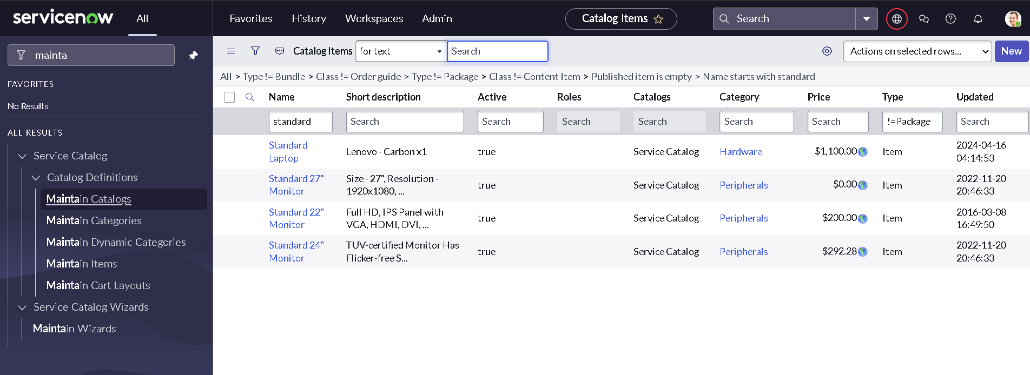

Step 3: Save and Publish Item Configuration
- Right-click the form header bar and click Save, or click the Update button in the top right corner.
- Verify that the Active checkbox on the Catalog Item is checked (true).
End-to-End Verification (Testing Activity 1 & 2)
To verify that the Flow assignment works as expected:
- Navigate to Service Portal (/sp) or Catalog Preview.
- Go to Hardware category and select Standard Laptop.
- Fill out required dynamic variables (e.g., Requester Name, Delivery Address) and click Order Now / Submit.
- Copy the generated Requested Item Number (e.g., RITM0010001).
- Return to ServiceNow backend and go to Service Catalog > Open Records > Items (sc_req_item).
- Open your submitted RITM record and verify:
  - Stage / State: Reflects the active flow execution state (e.g., Waiting for Approval or Fulfillment).
  - Related Lists (Approvals tab): Approvers are dynamically generated.
  - Related Lists (Catalog Tasks tab): Once approved, an sc_task appears with:
    - Short Description: Provision and Image Standard Laptop for [User]
    - Assignment Group: Hardware

Activity 3: Service Catalog Configuration & Approval Workflow Setup
Objective
Design and configure a Standard Laptop Order Catalog Item within the ServiceNow Service Catalog, complete with custom variable sets for user selections and an automated approval rule structure.
Step 1: Create the Service Catalog Item
- Navigate to Service Catalog > Catalog Definitions > Maintain Items.
- Click New to create a new Catalog Item record.
- Configure the item details:
  - Name: Standard Business Laptop
  - Catalogs: Service Catalog
  - Category: Hardware
  - Short Description: Order a standard pre-approved corporate laptop for employees.
  - Description: Provides standard hardware specifications (e.g., Intel i7, 16GB RAM, 512GB SSD, 14-inch Display).
  - Availability: Desktop and Mobile
- Click Save (or right-click the header and select Save).
Step 2: Add Catalog Variables & Variable Sets
In the Variables related list at the bottom of the form, add the necessary fields to capture requester choices:
Field Name | Type | Mandatory | Variable Details / Configuration
Requested For | Reference | Yes | Reference table: sys_user (Defaults to current user via default value javascript:gs.getUserID()).
Delivery Location | Reference | Yes | Reference table: cmn_location.
Laptop Model Specs | Select Box | Yes | Options: Standard (16GB RAM / 512GB SSD), High-Performance (32GB RAM / 1TB SSD).
Accessories Needed | Options / Checkbox | No | Options: USB-C Dock, Wireless Mouse, External Monitor, Laptop Bag.
Business Justification | Multi-Line Text | No (Yes for High-Perf) | Text box for operational reason for request.
Step 3: Configure Approval Rules & Execution Logic
- Scroll down to the Process Engine tab on the Catalog Item form.
- Under Flow, attach your published workflow (e.g., Automate Laptop Request - Hardware Task Creation).
- Define the approval sequence in your Flow/Process:
  - Auto-Approval: Orders under $\$1,000$ or standard configurations auto-approve and route straight to fulfillment.
  - Manager Approval: Orders over the price threshold or high-performance selections trigger a dynamic Ask for Approval step sending an approval request to the Requested For manager (sys_user.manager).
Step 4: Verification & Approval Flow Testing
- Go to Service Portal (/sp) and open Service Catalog > Hardware > Standard Business Laptop.
- Fill out the variable inputs (select requester, location, and model options) and click Order Now.
- Note the generated REQ (Request) and RITM (Requested Item) numbers.
- Navigate to Service Catalog > Approvals (or Self-Service > My Approvals as the approver):
  - Verify an entry exists with State = Requested.
  - Click Approve.
- Re-check the RITM record to confirm:
  - Approval State: Changes to Approved.
  - Stage: Advances to Fulfillment

Conclusion
Automating standard laptop procurement using ServiceNow Service Catalog and Flow Designer transforms IT Request Fulfillment from a manual, email-dependent task into a standardized digital workflow.
By integrating end-to-end process automation—from dynamic item selection and automated manager approvals to automatic Catalog Task (sc_task) generation and hardware assignment—the solution delivers key benefits:
- Reduced Provisioning Cycle Time: Streamlines approval handoffs and task routing, enabling hardware delivery in hours rather than days.
- Operational Efficiency: Minimizes administrative overhead for IT Service Desk teams by automatically routing tasks to the Hardware group.
- Full Auditability & Visibility: Maintains accurate status tracking across REQ, RITM, and SCTASK records, ensuring compliance and clear user visibility throughout the fulfillment lifecycle.
Future Scope & Enhancements
- IntegrationHub Vendor Automation: Connect Flow Designer to vendor APIs (e.g., Dell, HP, Lenovo) via IntegrationHub for automated direct-ship purchase orders when local stock is exhausted.
- Hardware Asset Management (HAM) Sync: Automate real-time updates to asset states and stockroom counts within the alm_hardware table upon task completion.
- Zero-Touch Provisioning: Integrate with enterprise tools like Windows Autopilot or Apple Business Manager to enable zero-touch device configuration straight out of the box.

